FIT2090: Business Information Systems and Processes

Assignment One

Submitted by:

Chris Wong

Rui Qin

Table of Contents

Task 1:

Question 1

Question 2

Question 3

Question 4

Question 5

Question 6

Task 2:

Question 1

Question 2

Question 3

Question 4

Task 1:

1)

|  |  |  |
| --- | --- | --- |
| Table of Entities and Activities (Annotated) | | |
| Entities | **Para** | **Activities** |
| Customer | 3 | 1. call or email SAM's clerk |
|  | 3 | 1. inform them about the requirement of mattress |
| Order entry (Clerk) | 3 | 1. Entering the PUID into the system |
| Computer | 3 | 1. Display information |
| Order entry (Clerk) | 3 | 1. Checks the existence of the client and Patient Unique Identifier (PUID) |
|  | 3 | 1. retrieve the patient information, mattress type/size needed from the database |
|  | 3 | 1. retrieve the delivery details from the database and lodge the order. |
| Computer | 4 | 1. generates a reference number saved in the Order event data |
| Order entry (Clerk) | 4 | 1. retrieve a list of mattresses that meet the requirement from the Mattress master data |
|  | 4 | 1. schedule for delivery |
|  | 4 | 1. inform SAM's drivers |
| drivers | 4 | 1. Receive |
| Order entry (Clerk) | 5 | 1. sends the invoice to the accountant |
| Customer's accountant | 5 | 1. pay and sends a copy of the invoice to the Customer |
| Order entry (Clerk) | 5 | 1. update the payment information in the Order event data |
| Customer | 6 | 1. claims from their health insurance send to clerk |
| Order entry (Clerk) | 6 | 1. collect |
|  | 6 | 1. send an invoice to their insurance company |

2)

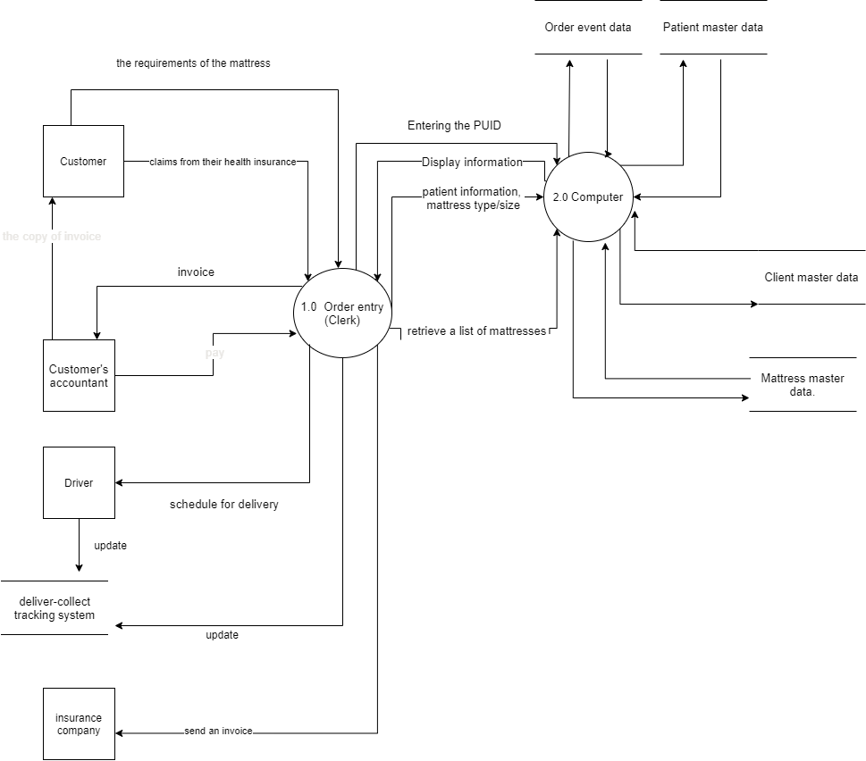

3)



4)

|  |  |  |  |
| --- | --- | --- | --- |
| Table of Entities and Activities (Annotated) | | | |
| Entities | **Para** | **Activities** | **Process** |
| Client | 3 | 1. Call or Email SAM Clerk | 1.0 Retrieving and validating patient information |
|  | 3 | 1. Request mattress requirements |
| Order Entry (Clerk) | 3 | 1. Receiving mattress information |
|  | 3 | 1. Entering PUID |
| Computer | 3 | 1. Display information |
| Order Entry (Clerk) | 3 | 1. Check existence of client and PUID |
|  | 3 | 1. Retrieves patient information, mattress type/size from database | 2.0 Reservation of Mattress |
|  | 3 | 1. Retrieve delivery details from database and lodge the order |
| Computer | 4 | 1. Generates reference number and saved in Order event data |
| Order Entry (Clerk) | 4 | 1. Schedule for delivery | 3.0 Delivering Mattress |
|  | 4 | 1. Inform SAM drivers |
| Drivers | 4 | 1. Receive delivery information |
|  | 4 | 1. Conduct inspection of mattress |
|  | 4 | 1. Inspect report on deliver-collect tracking system |
|  | 4 | 1. Deliver |
| Order Entry (Clerk) | 5 | 1. Sends invoice to accountant | 4.0 Payment |
| Accountant | 5 | 1. Payment delivered |
| Order Entry (Clerk) | 5 | 1. Update payment in Order event data |
| Customer | 6 | 1. Lodge insurance claim and send to clerk |
| Order Entry (Clerk) | 6 | 1. Receive insurance claim and information |

5)

6)

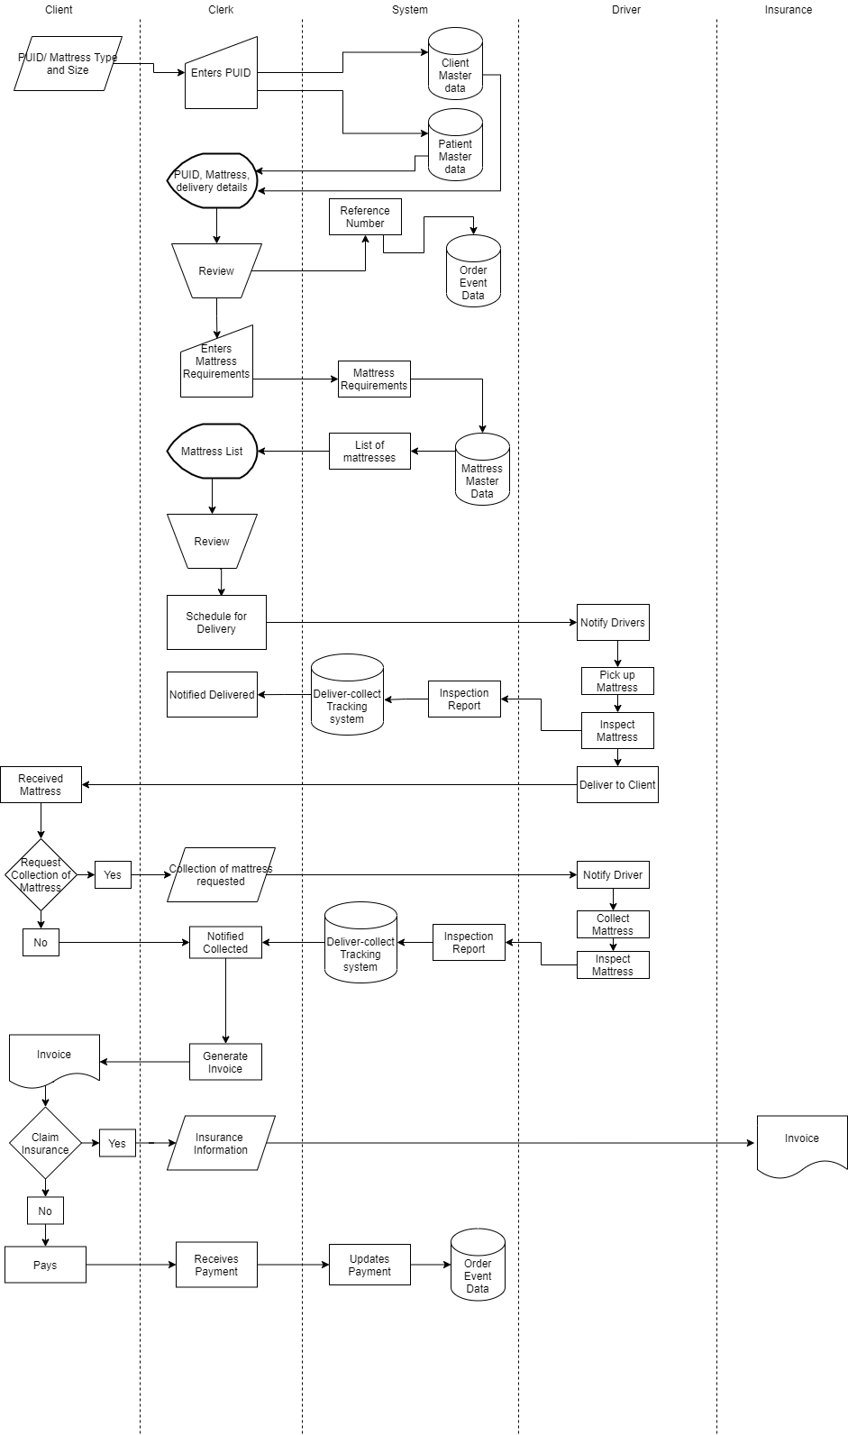

Task 2:

Question 1:

Organisations who adopt the use of Business Information System (BIS) concepts are more than likely to have an effective business practice. By implementing concepts of BIS, it minimises human error and maximises work efficiency within the organisation. Without BIS practices, organisations can fall apart as they could be operating on a framework that could be not effective in real practices as potential work efficiency is decreased, organisation data is mismanaged, and time efficiency is poor. Hence, investing in BIS practices in an organisation is hugely beneficial for operations and business goals in the future. An example of a business that did not adopt BIS concepts and practices is Sanitised Air Mattresses.

Question 2:

Sanitised Air Mattresses (SAM) business practices are found to be ineffective in the long term as there are many inefficient processes as described in the scenario. Firstly, the mattresses meet requirement checking is too late. This process is inefficient as when the clerk pushes the reference number to the database, the clerk then checks the mattresses and found no stock, then the clerk has to nullify the reference number, if checking stock before creating a number, it will not create a lot of invalid numbers. Secondly, the whole system confirms the rental before they get the money, the driver has to delivering and collecting and nearly half of the process is in vain if the client does not have money, even the client claims the insurance, the clerk should receive paid before and refund. Another time inefficiency within SAM is when drivers record the condition of the mattress before and after collection is uploaded by QR code to the deliver-collect tracking system. In the given scenario, the deliver-collect tracking system is a completely different system from the central computer system. This complicates the overall system when the clerk is required to review the condition of the mattress and its delivery status. If such a mattress goes missing, there could be a data mismatch and could result in the mattress being mishandled and responsibilities cannot be placed either on the client or the company. Therefore, SAM needs to employ BIS concepts and practices in their operations which will enhance the longevity and meet its business goals.

Question 3:

To improve business practices in SAM, SAM should use the “Six Sigma” concepts to improve its business practices to minimise mistakes and defects within SAM’s business processes (Adam, 2021). Six Sigma’s approach follows a method known as DMAIC (Define, Measure, Analyse, Improve, and Control). It helps identify and define faulty processes in the system by measuring the initial performance of the process and identify potential problems within the process. After the elimination of the potential problems, conduction by measuring the performance after the eliminations with providing whether the potential problems had an impact on the efficiency of the operations. If it does impact the efficiency of the operations, it is safe to eliminate the problem from the process and increase the efficiency of the process. For example, in SAM, clients would have to phone or email the clerk to place the order. This increases the workload of the clerk and decreasing the efficiency of the process. By implementing a web order system with proper formatting, the clerk will no longer be needed to take phone calls or respond to emails therefore the clerk can focus on other tasks they require to do. In addition, the clerk has many tasks which could be replaced by system integration of delivery-tracking system and order event data. The integration of these two systems will reduce the clerk’s workload by not having to update the status of the mattress and looking for data mismatches. By implementing the Six Sigma into SAM business practices will hugely improve the efficiency of processes and could result in an increase in sales, support, and happiness with customers and employees. Therefore, businesses will more likely achieve their business goals.

References:

Inspired Techs. (2016). Why information systems are so important to your businesses. Retrieved from <https://www.inspiredtechs.com.au/why-information-systems-are-so-important/>

Bourgeois, D., & Bourgeois,D.T. (2019). Information systems for business and beyond. Retrieved from <https://bus206.pressbooks.com/chapter/chapter-9-info-systems-strategic-advantage/>

Hayes, A. (2021). Six Sigma. Retrieved from [Six Sigma Definition (investopedia.com)](https://www.investopedia.com/terms/s/six-sigma.asp)